**Question 1:**

Find out the mail servers of the following domain:

Ibm.com

Wipro.com

**IBM.COM**

Mail exchanger:

ibm.com mail exchanger = mx0a-001b2d01.pphosted.com

IP Address: 148.163.156.1

ibm.com mail exchanger = mx0b-001b2d01.pphosted.com

IP Address: 148.163.158.5

**Question 2:**

Find the locations, where these email servers are hosted.

Mail server Location:

California, United States of America

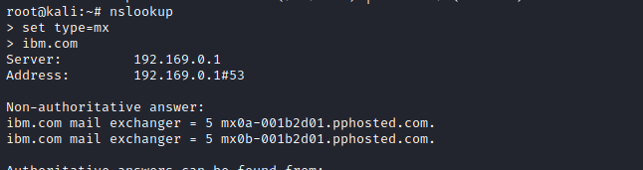

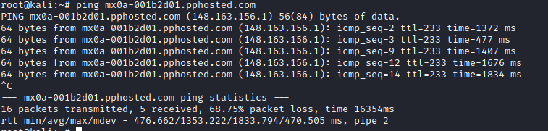

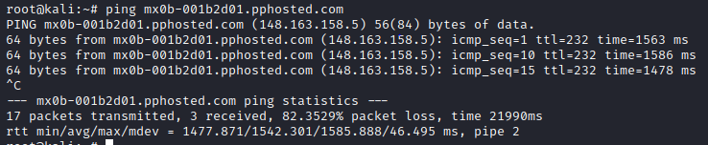

**Wibro.com**

Mail exchanger: mail.pickelhost.com

IP Address: 18.237.196.55

**Question 2:**

Find the locations, where these email servers are hosted.

2.Mail server Location:

Oregon, United States of America

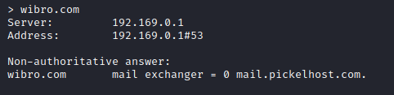

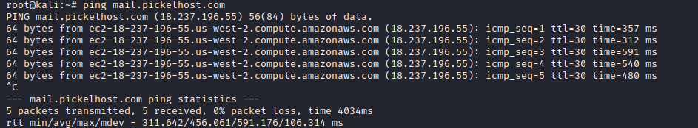

**Question 3:** Scan and find out port numbers open 203.163.246.23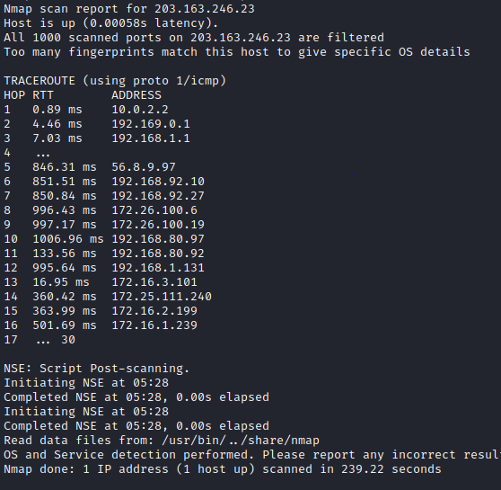

**Question 4:**

Install Nessus in a VM and scan your laptop/desktop for CVE.